**Sunkari Manohar**

**Assessment 2 – 29/12/2023**

Today we did hands on practice for pyspark programs using Azure data bricks.

First we need to open Azure data bricks service in Microsoft azure portal.

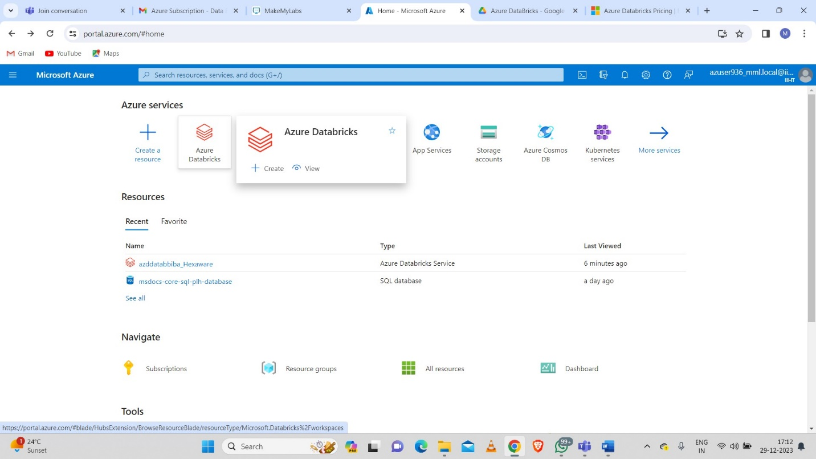

Then we need to select the resource group which we want to use.

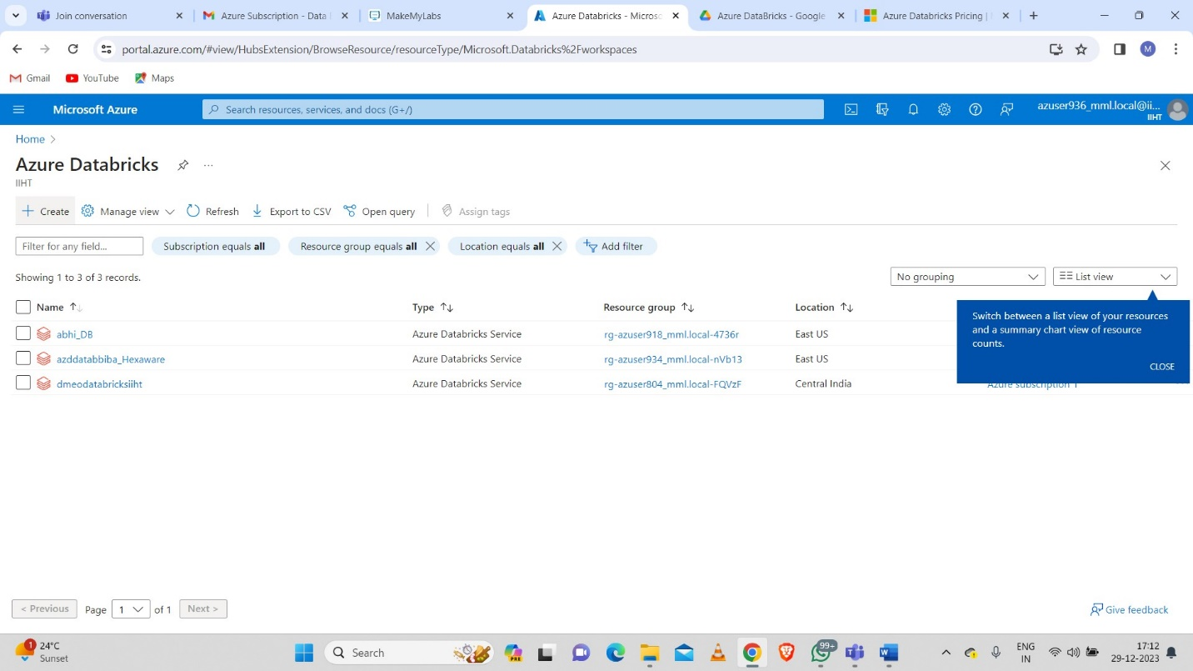

**Cluster creation:**

First we need to click on new tab:

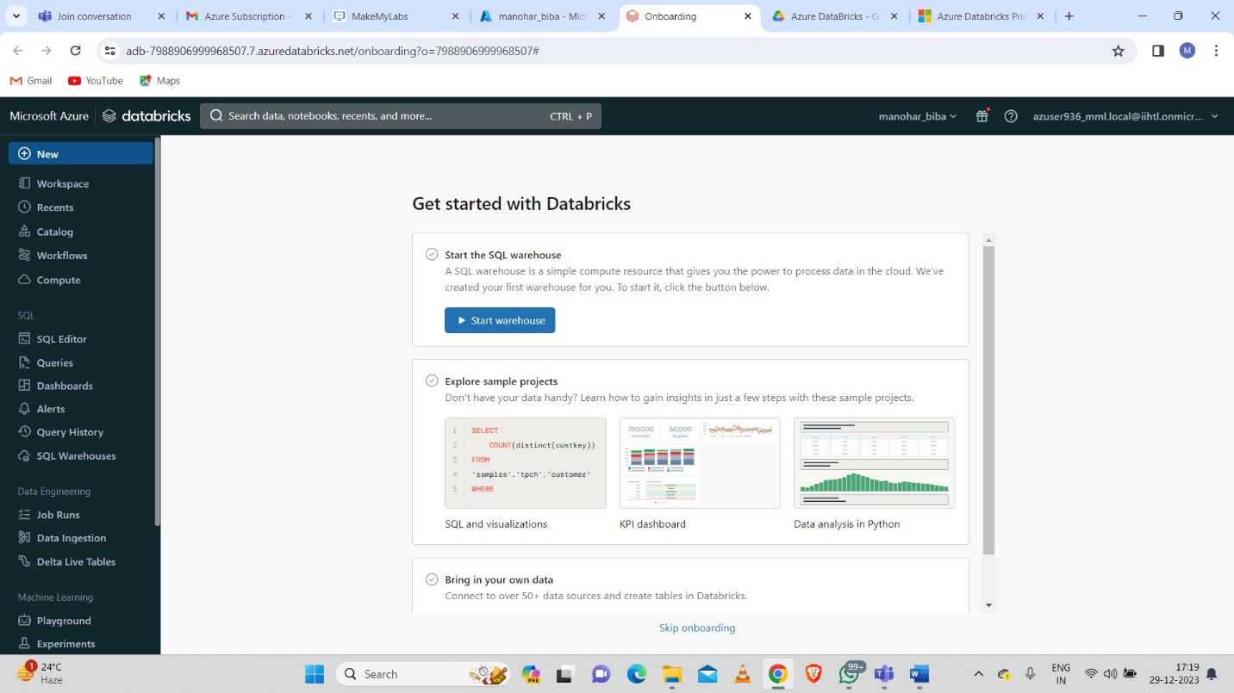

Then we need to click on cluster tab:

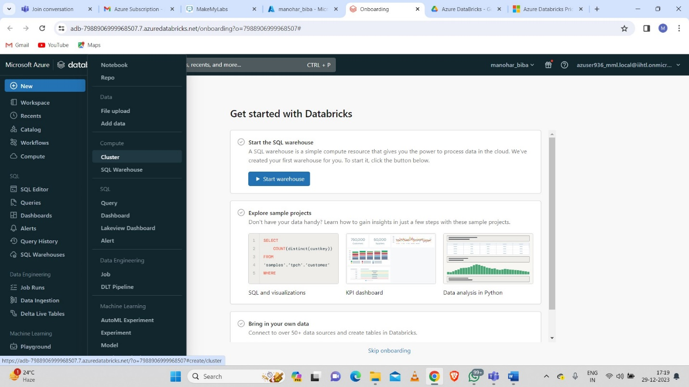

After clicking on cluster button then we need to select the cluster name and more details which we want in cluster creation:

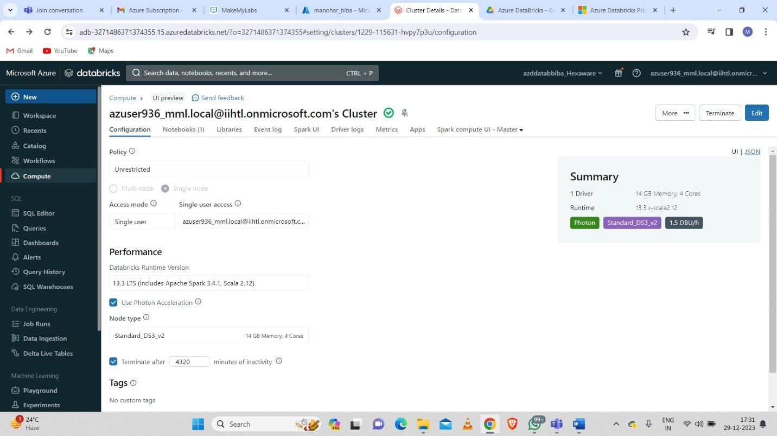

After cluster creation we created a new notebook to execute some pyspark programs.

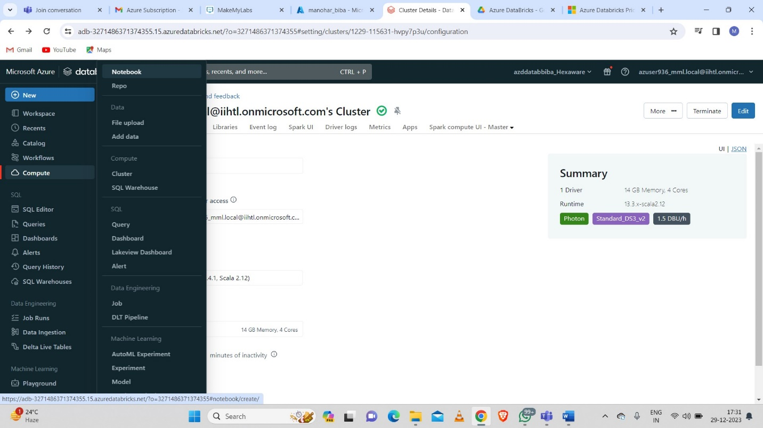

**Example 1:**

**Converted column to python list:**

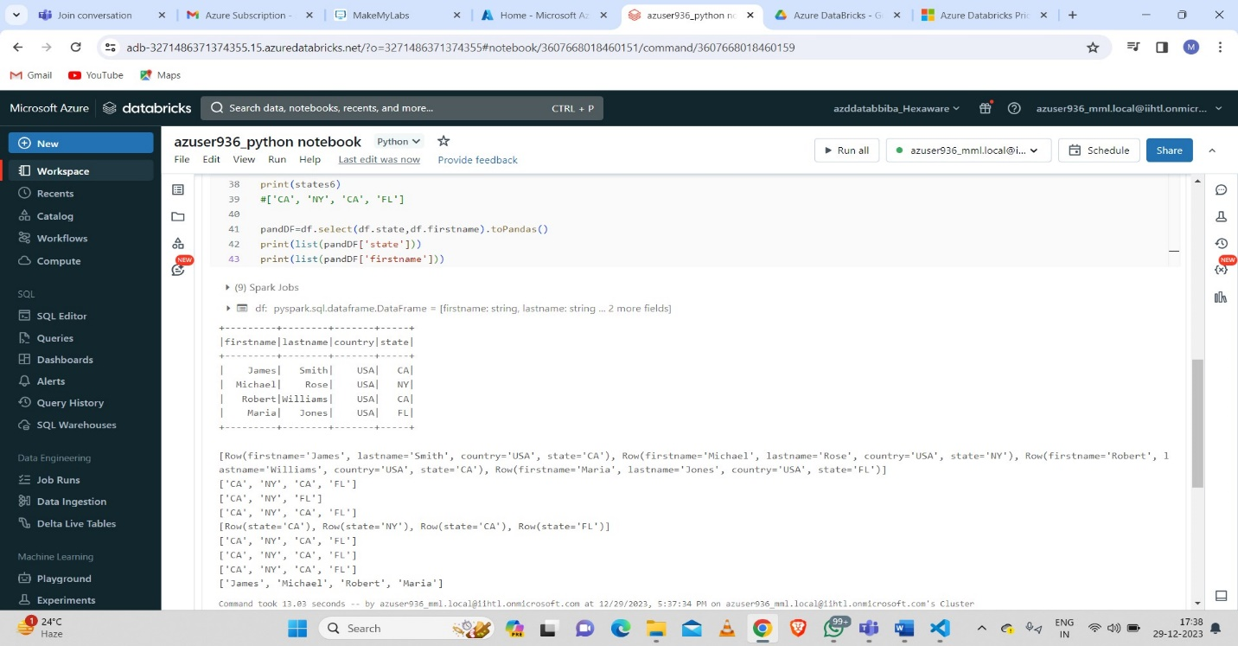

**Example 2:**

**Date Difference:**

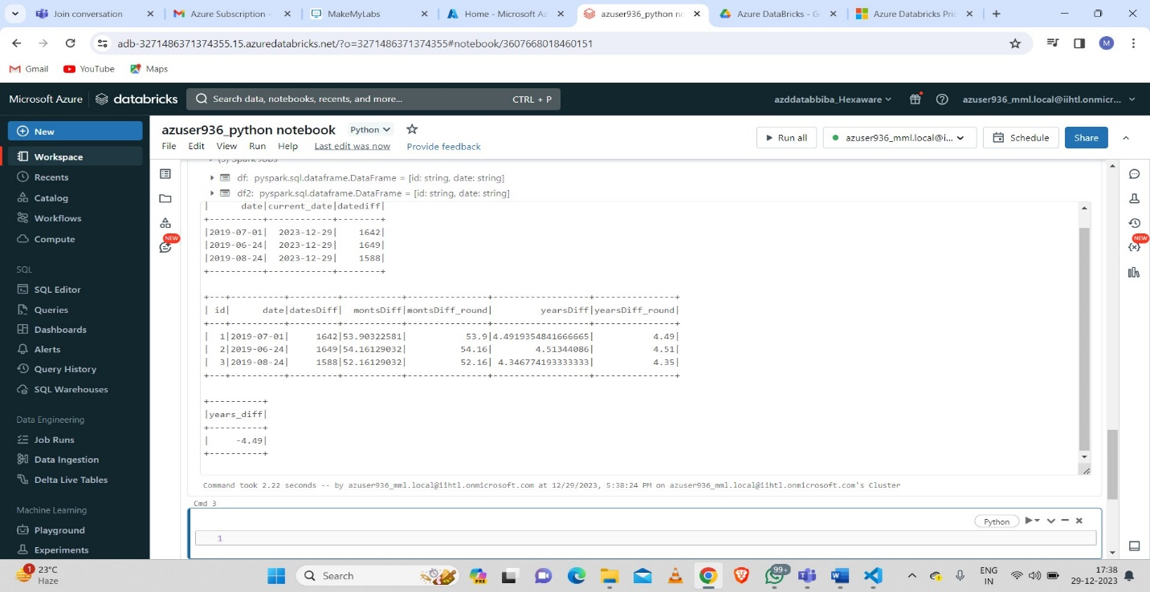

**Example 3:**

**Data Collect:**

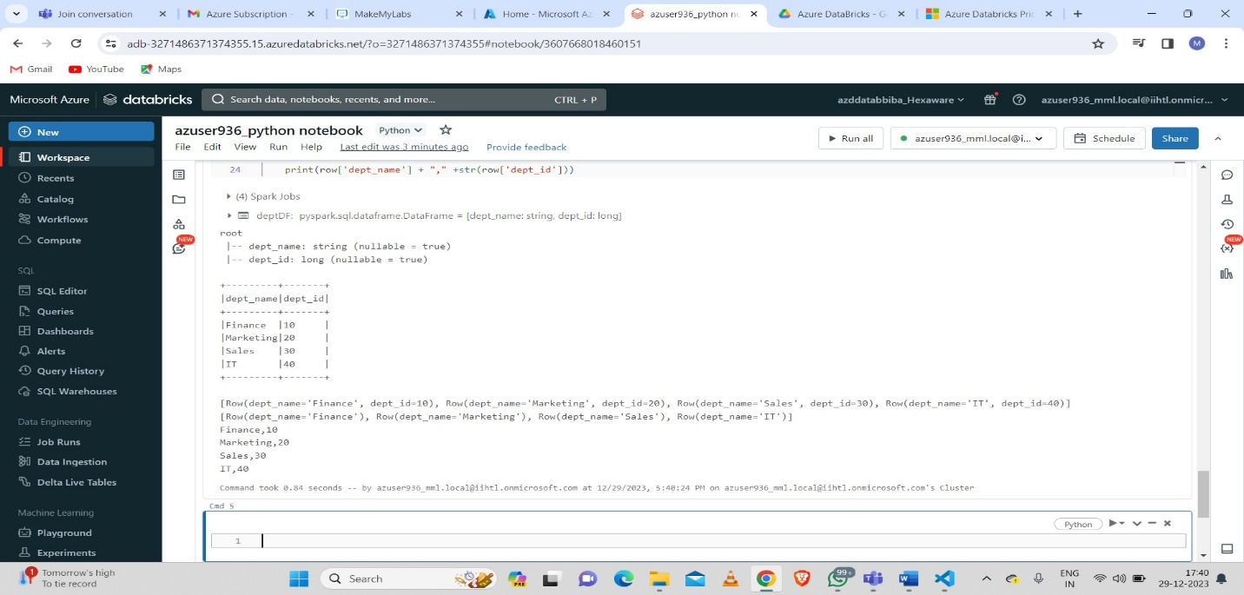

**Example 4:**

**Data frame creation:**

